**Ex No:04 Sub Queries**

**Aim:**

To work with Sub Queries

**Procedure:**

Step1: Open Run SQL on Command line and connect to SQL .

Step 2: Then work with database using SQL queries

**1.SELECT :**

**Syntax:** SELECT Column_name FROM table_name WHERE column_name expression operator(SELECT column_nameFROM table_name WHERE condition);

**Code:** select * from tution where rollno in (select rollno from tution where shift=1);

**OUTPUT:**

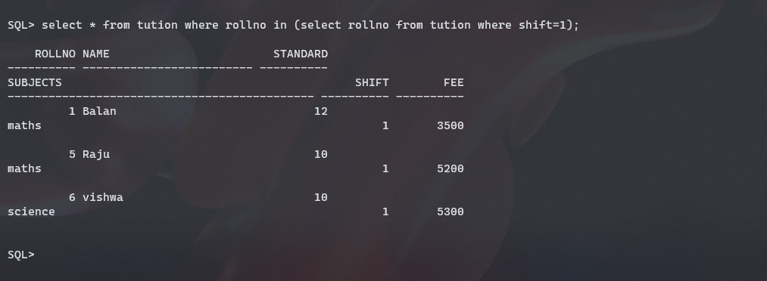

**2.INSERT:**

**Syntax:** INSERT INTO table1 SELECT * FROM table2 WHERE condition;

**Code: sql>** create table tution3 as select * from tution where rollno=1;

**sql>**insert into tution3 (rollno,name,standard,subjects,shift,fee) select * from tution where rollno=2;

**OUTPUT:**

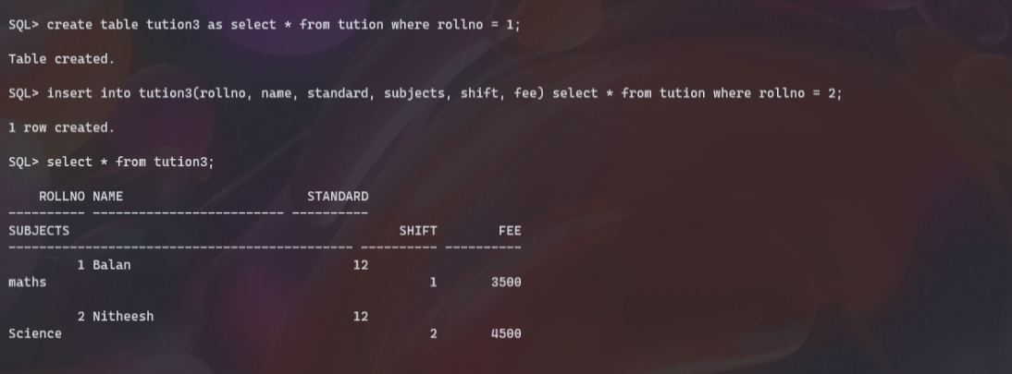

**3.UPDATE:**

**Syntax:** UPDATE table1 SET column_name1=value WHERE column_name in (SELECT column_name FROM table2 WHERE condition);

**Code:** update tution3 set standard=10 where fee in (select fee from tution where fee=3500);

**OUTPUT:**

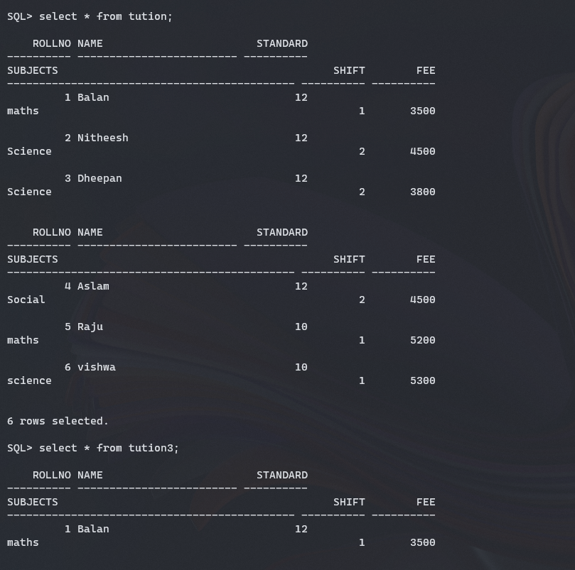 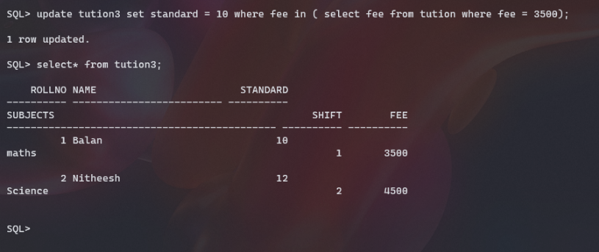

**4.DELETE:**

**Syntax:** DELETE FROM table1 WHERE column_name in (SELECT column_name FROM table2 WHERE column_name=value);

**Code:** delete from tution3 where shift in(select shift from tution3 where fee=4500)

**OUTPUT:**

